TWIN RIVERS PARISH COUNCIL

THE ORDINARY MEETING OF THE COUNCIL WILL BE HELD
IN THE VILLAGE HALL ON TUESDAY 14th October 2025

You are summoned to attend.
Public Forum 7.30-7. 40pm.Any members of the public attending the meeting may be given (at the chairman’s discretion) a combined 10-minute time slot to address councillors on any items of concern or interest. After this period the public are welcome to stay for the full parish council meeting but CANNOT speak nor offer advice/opinion on any matter. This public participation is NOT part of the parish council meeting and as such there are no rights to record this part of the meeting in any way.

AGENDA

Apologies for absence.

Minutes

The minutes of the last meeting held on 9th September 2025 have been circulated to all councillors prior to the meeting.

Declarations of Interest.

Declaration of Interest – The parish councils (Model Code of Conduct Order 2011). To record any declarations of interest by any member in respect of items on this agenda). Members declaring interests should identify the agenda item and type of interest being declared.
Financial Matters

Current account - £

Cow lane Current account -

Business reserve £

Cheques
Clerks wages
Vision ICT £439.76

ONGOING ISSUES

Ousefleet Community Hall update.

Health and Safety Issues.

Cow Lane

PLANNING
Erection of a two storey side extension Location: Honeysuckle Cottage Main Street Whitgift East Riding Of Yorkshire DN14 8HL

Planning application NY/2025/0113/FUL has been published and is open for comments until 31 October. The application is to drill through the chalk water aquifer at Foxholes, close to the boundary with Wold Newton, that supplies water to the whole of East Riding of Yorkshire and beyond.

COUNCILLOR ISSUES
Two co options exist, Advertised on the website, noticeboards and in the Goole Times.

National grid

Whitgift lighthouse

Speeding

Phone Box

Ousefleet village hall roof

Tree

Penfold

Information Board

CCTV

Christmas tree

Wreath

Defib

CORRESPONDENCE

WARD COUNCILLOR’S REPORTS

ITEMS FOR THE NEXT AGENDA

Date and place of the next meeting

11th November 2025. 7:30pm Ousefleet village hall

Signed

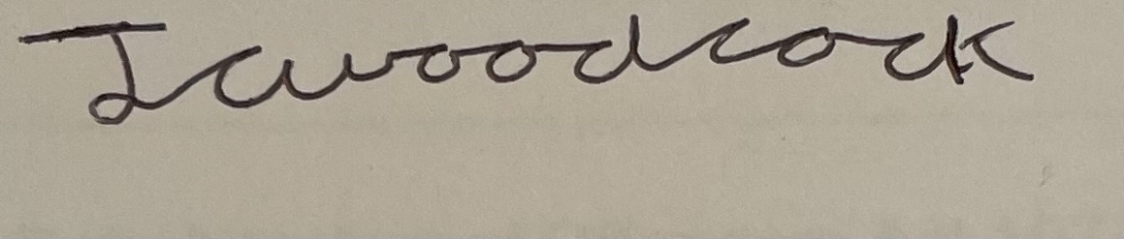
James Woodcock- Clerk and RFO

